**NUST SCHOOL OF ELECTRICAL ENGINEERING AND COMPUTER SCIENCE**

|  |  |
| --- | --- |
|  |  |

|  |  |
| --- | --- |
| **Faculty Member:____________________** | **Dated: ________________** |
| **Semester:_____________** | **Section: ________________** |

**EE- 222: Microprocessor Systems**

**Lab # 4: Writing Assembly Programs**

|  |  |  |  |  |
| --- | --- | --- | --- | --- |
| **Name** | **Reg. No.** | **Report Marks / 10** | **Viva Marks / 5** | **Total/15** |
|  |  |  |  |  |
|  |  |  |  |  |
|  |  |  |  |  |

**Objective:**

Write an assembly program that adds the following two 16-bit images

(Each pixel/element is of 16-bits) and displays the resultant memory values on the screen. Use appropriate addressing scheme.

**[10 marks]**

**Jump Instruction:**

A conditional jump instruction branches to a destination label when a flag condition is true.

*Jcond destination*

Or

*Jmp destination*

**Jumps Based on Specific Flag Values.**

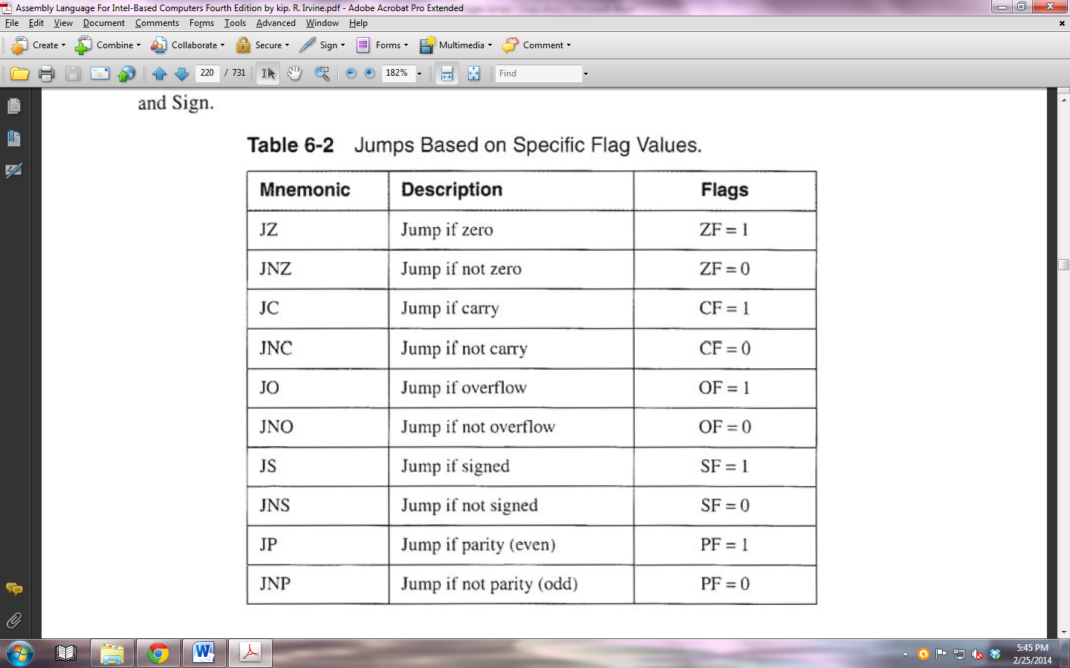

**Equality Comparisons**



**Unsigned Comparisons**

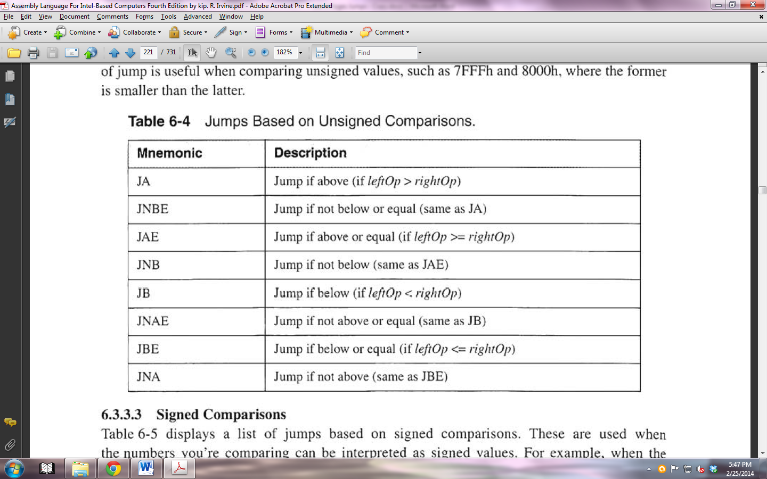

**Signed Comparisons**

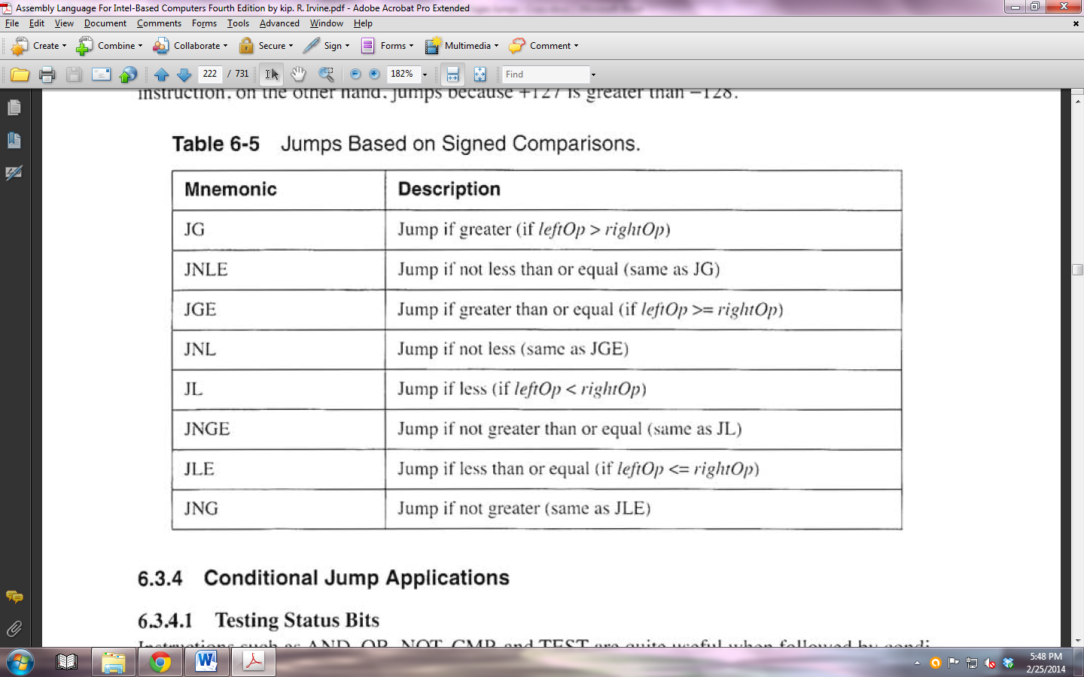

***Image A***

***Image B***



